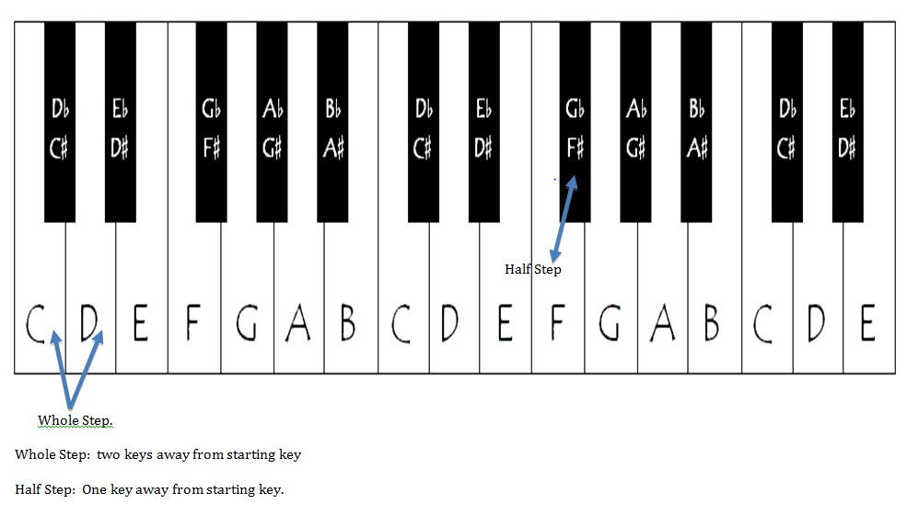
Major Scales: WWHWWWH
Minor Scales: WHWWHWW
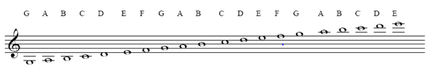
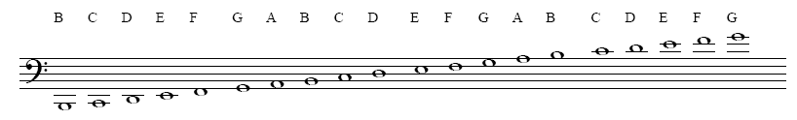
Major Key Chord Progressions
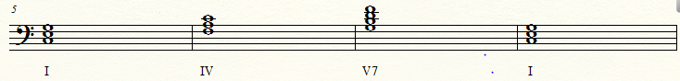
Minor Key Chord Progressions
